# Workshop: Petstagram Full Description

We will be creating a complete Django project called **"Petstagram"** throughout this module. The project will cover the following **functionalities**: user **registration**, **login,** and **logout**; each user can **add pets** to their profile and **upload pet photos**; a user can **view all photos** of pets, open **details**, can **like** and **comment** on a photo. Each user can **edit** and **delete** **their** **photos** and **pet** information.

You can directly dive into the app here: <https://softuni-petstagram.herokuapp.com/>

## URLs

Home Page: <http://127.0.0.1:8000/>

Registration Page: <http://127.0.0.1:8000/accounts/register/>

Login Page**:** <http://127.0.0.1:8000/accounts/login/>

Profile Details Page: [http://127.0.0.1:8000/accounts/profile/<int:pk>/](http://127.0.0.1:8000/accounts/profile/%3cint:pk%3e/)

Profile Edit Page: [http://127.0.0.1:8000/accounts/profile/<int:pk>/edit/](http://127.0.0.1:8000/accounts/profile/%3cint:pk%3e/edit/)

Profile Delete Page: [http://127.0.0.1:8000/accounts/profile/<int:pk>/delete/](http://127.0.0.1:8000/accounts/profile/%3cint:pk%3e/delete/)

Pet Add Page: <http://127.0.0.1:8000/pets/add/>

Pet Details Page: [http://127.0.0.1:8000/pets/<str:username>/pet/<slug:petname>/](http://127.0.0.1:8000/pets/%3cstr:username%3e/pet/%3cslug:petname%3e/)

Pet Edit Page: [http://127.0.0.1:8000/pets/<str:username>/pet/<slug:petname>/edit/](http://127.0.0.1:8000/pets/%3cstr:username%3e/pet/%3cslug:petname%3e/edit/)

Pet Delete Page: [http://127.0.0.1:8000/pets/<str:username>/pet/<slug:petname>/delete/](http://127.0.0.1:8000/pets/%3cstr:username%3e/pet/%3cslug:petname%3e/delete/)

Photo Add Page: <http://127.0.0.1:8000/photos/add/>

Photo Details Page: [http://127.0.0.1:8000/photos/<int:pk>/](http://127.0.0.1:8000/photos/%3cint:pk%3e/)

Photo Edit Page: [http://127.0.0.1:8000/photos/<int:pk>/edit/](http://127.0.0.1:8000/photos/%3cint:pk%3e/edit/)

## Models

### User Profile

* **Username**
* **Password**
* **Email** **Address**

**Note**: the user registers with the information provided above (all required)

* **First** **Name** – it should have **at least 2 chars**, **max - 30 chars**, and should consist **only of letters**
* **Last Name** - it should have **at least 2 chars**, **max - 30 chars**, and should consist **only of letters**
* **Profile Picture** – the user can link their picture using a **URL**
* **Gender** – character field with **choices**, the user can choose one of the following: "**Male**", "**Female**", and "**Do not** **show**"

Other:

* When the **user is deleted** all its **photos**, **pets**, **comments** and **likes** should be **deleted too**

### Pet

The user **must** provide the following information when adding a pet:

* **Name** - it should consist of a **maximum of 30 characters**. All pets' names should be **unique for that user**
* **Personal Pet Photo** - the user can link a picture using a URL

The user **may** provide the following information when adding a pet:

* **Date of Birth** - pet's day, month, and year of birth

Other:

* **Slug** - a slug automatically generated using the **pet's name**
* When a pet is deleted **NONE** of its **photos** **should be deleted**

### Pet's Photo

The user **must** provide the following information when uploading a pet's photo:

* **Photo** - the user can **upload** a picture **from storage**, the **maximum** **size** of the photo can be **5MB**

The user **may** provide the following information when uploading a pet's photo:

* **Description** - a user can write any description of the photo, it should consist of a **maximum of 300 characters** and a **minimum of 10 characters**
* **Location** - it should consist of a **maximum of 30 characters**
* **Tagged Pets** - the user can tag **none, one or many** **of** **all pets**. There is **no limit** on the number of tagged pets

Other:

* Date of publication - when a picture is **added** **or edited**, the date of publication is **automatically generated**
* When a **photo is deleted** all its **comments** and **likes** should be **deleted too**

### Comment

The user **must** provide the following information when commenting on a picture:

* **Comment** **Text** - it should consist of a **maximum of 300 characters**

Other:

* **Date and Time of Publication** - when a comment is created (only), the date of publication is **automatically** **generated**

### Like

* Should **connect the user** **to the** **photo** so it's known which user which photo has liked

## Structure

### Navigation Bar

At the top of each page there is a navigation bar that has the following buttons:

* **Petstagram** button that leads to the home page
* **Add Pet** button that leads to the pet add page
* **Add Photo** button that leads to the photo add page
* **Login** button that leads to the login page (visible only to unauthenticated users)
* **Register** button that leads to the register page (visible only to unauthenticated users)
* **Profile** button that leads to the user profile details page(visible only to authenticated users)
* **Logout** button that logs out the logged-in user (visible only to authenticated users)

### Home Page

The home page consists of a search bar, where users can **search for pet photos by a pet name**, and pet photos (posts). When there **are pets photos**, the user sees posts, each consisting of:

* The owner's **name** (or **username** if first/ last name is **NOT** provided) and their **profile picture**
* The **location** (if one is added)
* The pet **photo**
* **Like** button
  + When the user clicks on the **white heart button** they **like the picture**, and the **heart turns red** - it is considered **one like** and should be updated in the counter (below)
  + When the user **clicks on an already liked picture** (on the read heart button) they **unlike** the picture, and the **heart turns white** - the **one like should be subtracted** from the total count (below)
  + Each user can do the like/unlike cycle an unlimited number of times
* **Share** buttons
  + When the user clicks on the **share button** the **URL in the address bar is copied** in the Clipboard.
* The total **count of likes** for the photo
* The **tagged** **pets** (if any are added) - if there is **more than one pet** tagged, they must be shown on **different lines**
* "**See Details**" button that leads to the **photo detail page**
* **Date** of publication or edition
* **Comment** **Form** that users can use to add comments to the photo

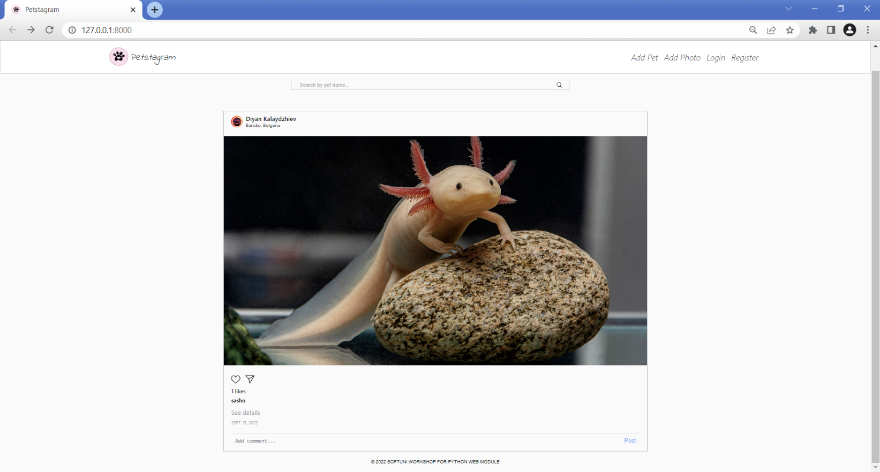

### 404 Page Not Found

When the user tries to reach an **invalid path**, the app should **load the 404 template**. It consists of:

* Navigation bar
* "**Uh oh, something broke. Error 404 - page not found.**" text
* "**Return to Petstagram**" button which leads to the home page.

### Registration Page

The visible fields when **creating** a profile are "**Username**", "**Email**", and "**Password**" fields. When the button "**Register**" is clicked, the **profile is created**, and it **redirects to the Login page**. There is also a "**Log in**" button that leads to the **Login page**:

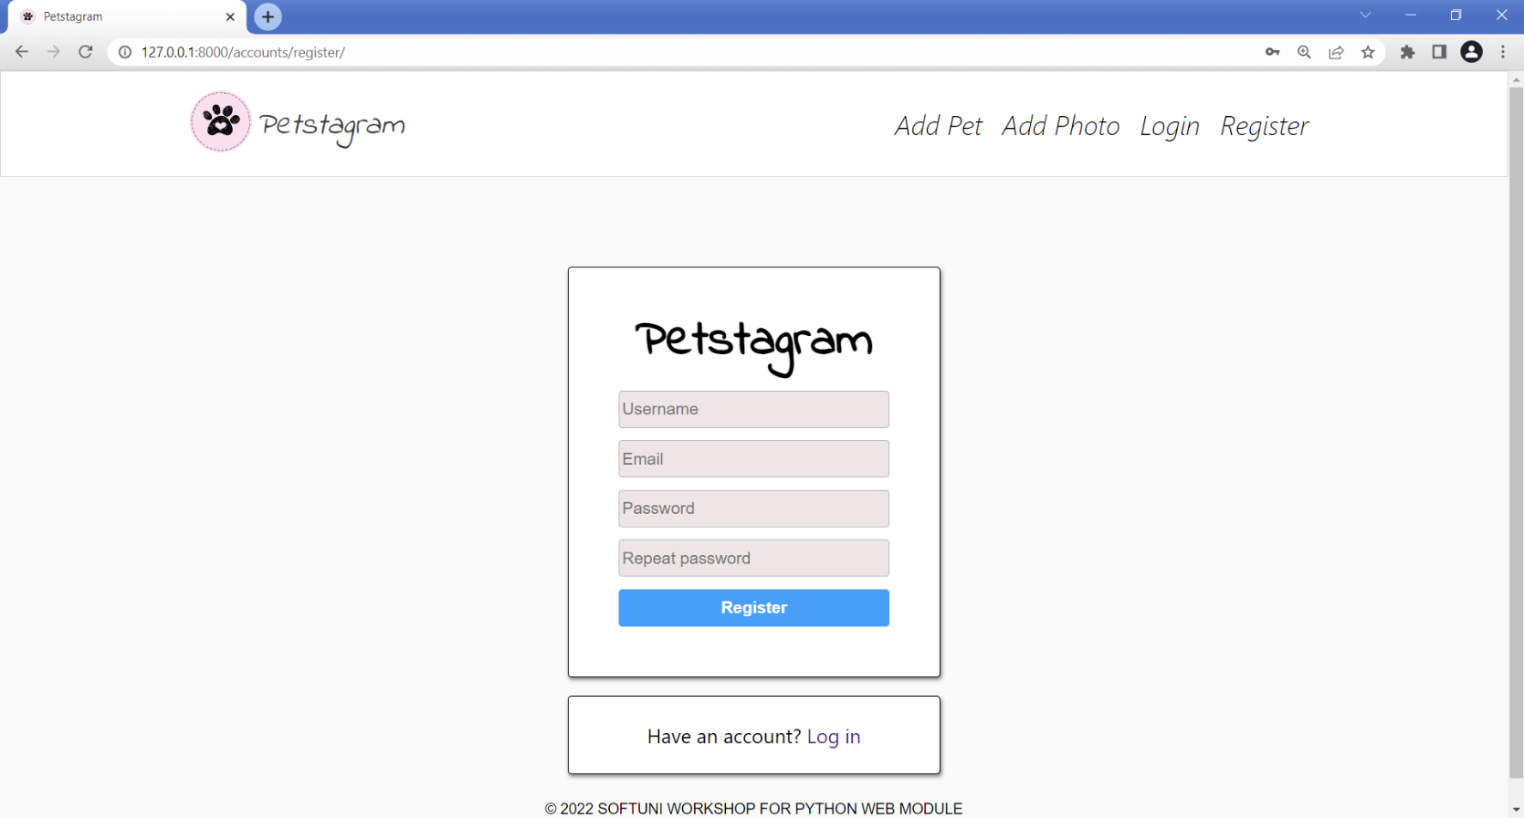

### Login Page

The visible fields when **login** to a profile are "**Username**" and "**Password**". When the button **"Log in"** is clicked, the user is logged in and **redirected** **to the** **Home page**. There is also a "**Register**" button that **leads to the register page**:

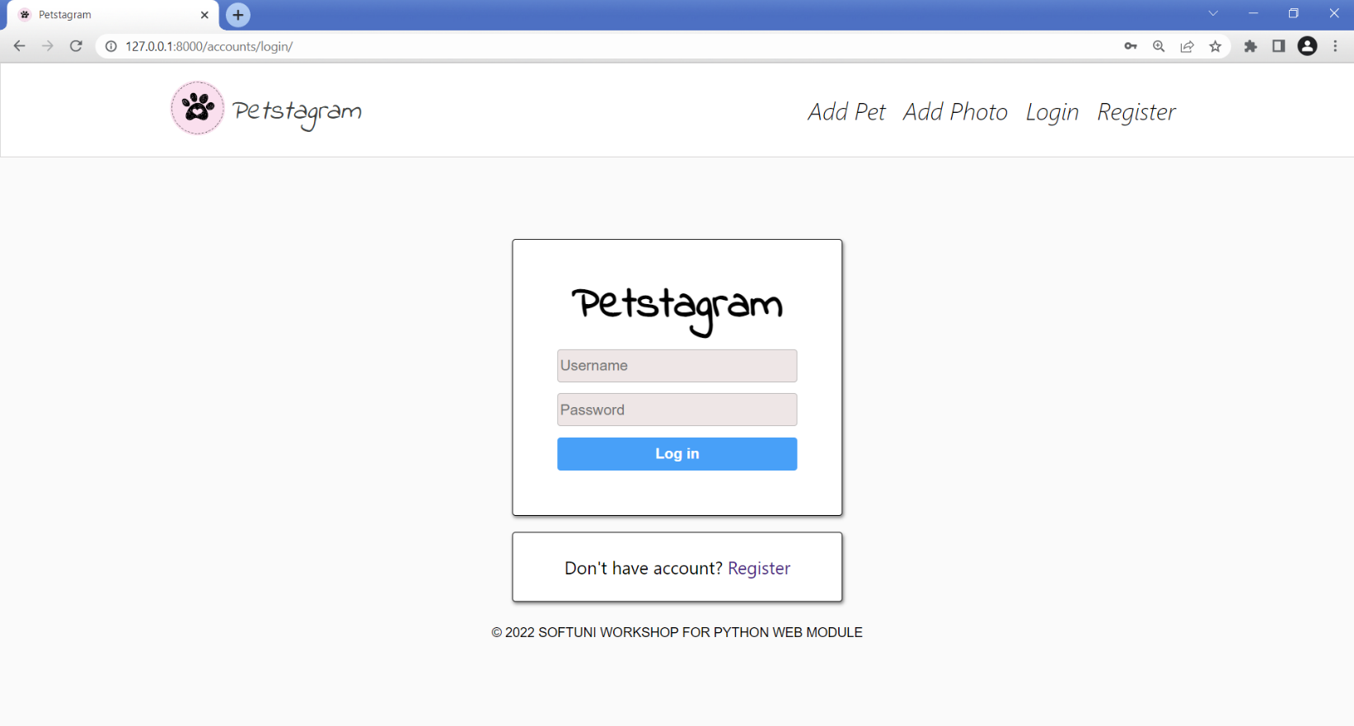

When the **user is logged in**, they can see the buttons "**Profile**" and "**Logout**" in the navigation bar:

### Profile Details Page

The profile details page consists of:

* The user profile **picture**; if the user has **NOT** added a profile picture, the **default image** should be shown
* The user **username**
* A **edit** profile button and a **delete** profile button
* The total **number of photos** added from the user
* The total **number of pets** added from the user
* The total **number of likes** collected by the user's photos
* The **email address** of the user
* A "**No Posts Yet**" text when the user has **NOT** uploaded any photos yet; or the photos themselves.

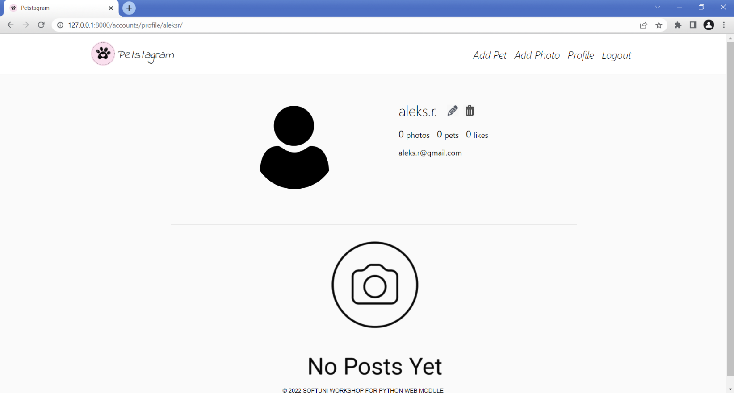

You can add a **first name** and a **last name**, **gender** ("Male" or "Female"), and a **personal image**:

### Profile Edit Page

The visible fields when **editing** the profile are "**Username**" and "**First Name**", "**Last Name**", "**Email**", "**Image**" and "**Gender**". When the button "**Edit**" is clicked, the **profile is edited**, and redirected to the **profile details page**: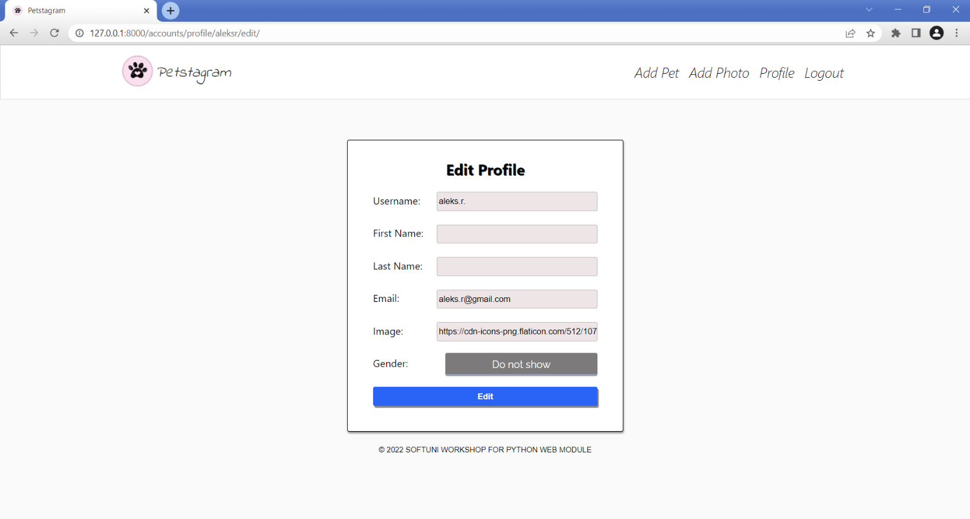

### Profile Delete Page

On the profile delete page there is a "**Are you sure you want to delete your profile?**" text and a "**Yes**" and " **Go Back**" buttons. If the user clicks on the "**Yes**" button the **profile is deleted**, **and** **all the user's** **photos**, **pets**, **comments** and **likes**, and the user is **redirected to the Home page**. If the user clicks on the "**Go back**" button, they are **redirected to the profile details page**: Graphical user interface, text, application

### Pet Add Page

The **visible fields** when adding a pet are "**Pet name**", "**Date of birth**", and "**Link to image**":

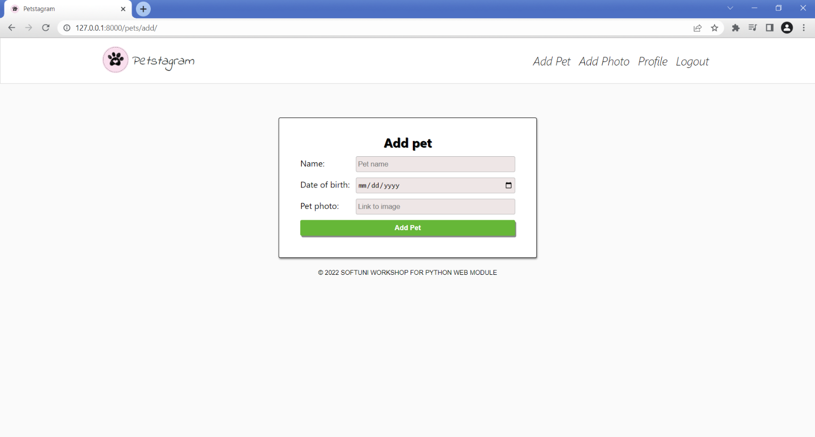

When the user **successfully adds a pet**, they are **redirected to their profile details page**, where their pets are visible:

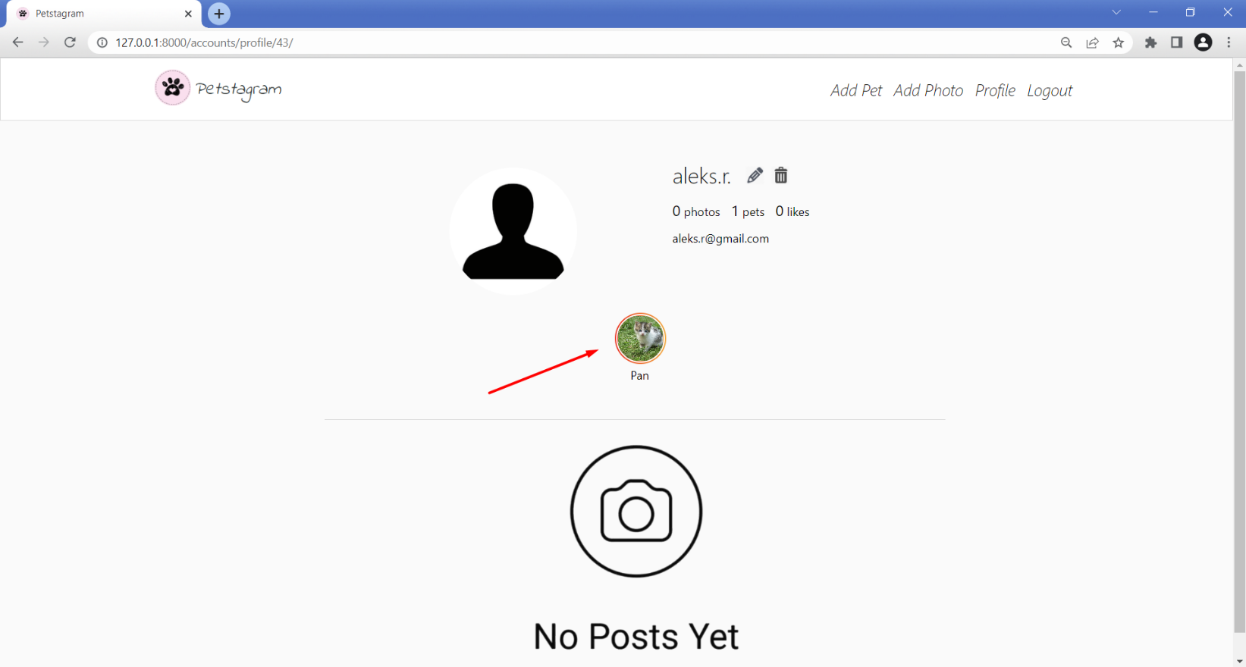

### Pet Details Page

The pet details page consists of:

* The pet **picture**
* The pet **name**
* **Edit** and **delete** buttons (visible only to their owner)
* The total **number of photos** that the pet was tagged on
* The **birthdate** of the pet (if one is added)
* A "**No Posts Yet**" text when the user has **NOT** uploaded any photos yet;

The **edit** button leads to the **pet edit page**. The **delete** leads to the certain **pet delete page**. 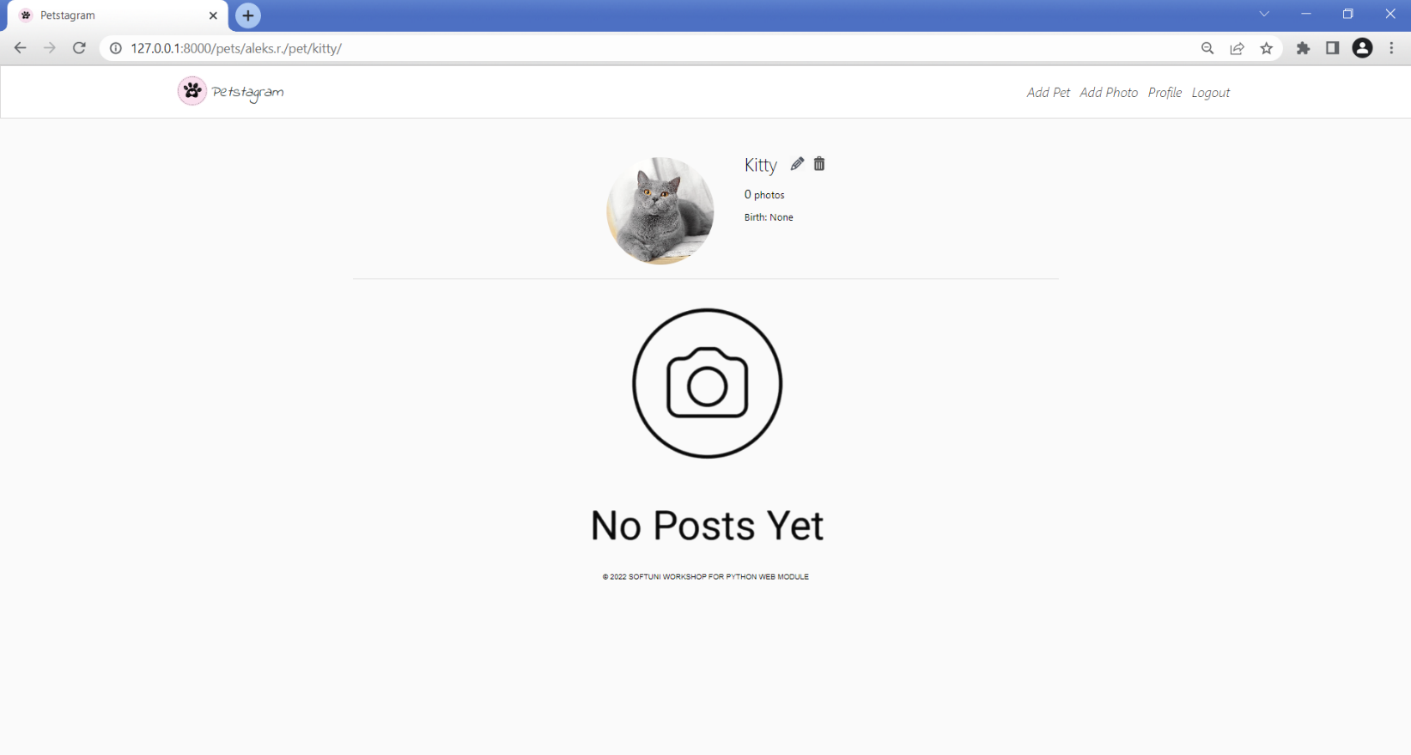

When the pet is **tagged** all **their photos are shown** as posts (same as on the Home page):

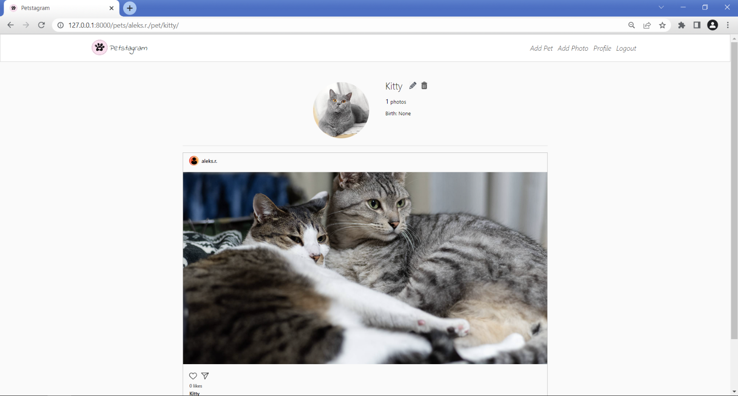

### Pet Edit Page

The visible fields when editing pet info are "**Pet name**", "**Date of birth**", and "**Link to image**". When you click on the "**Edit**" button, the **pet info is updated**, and the user is redirected to the **pet details** page: 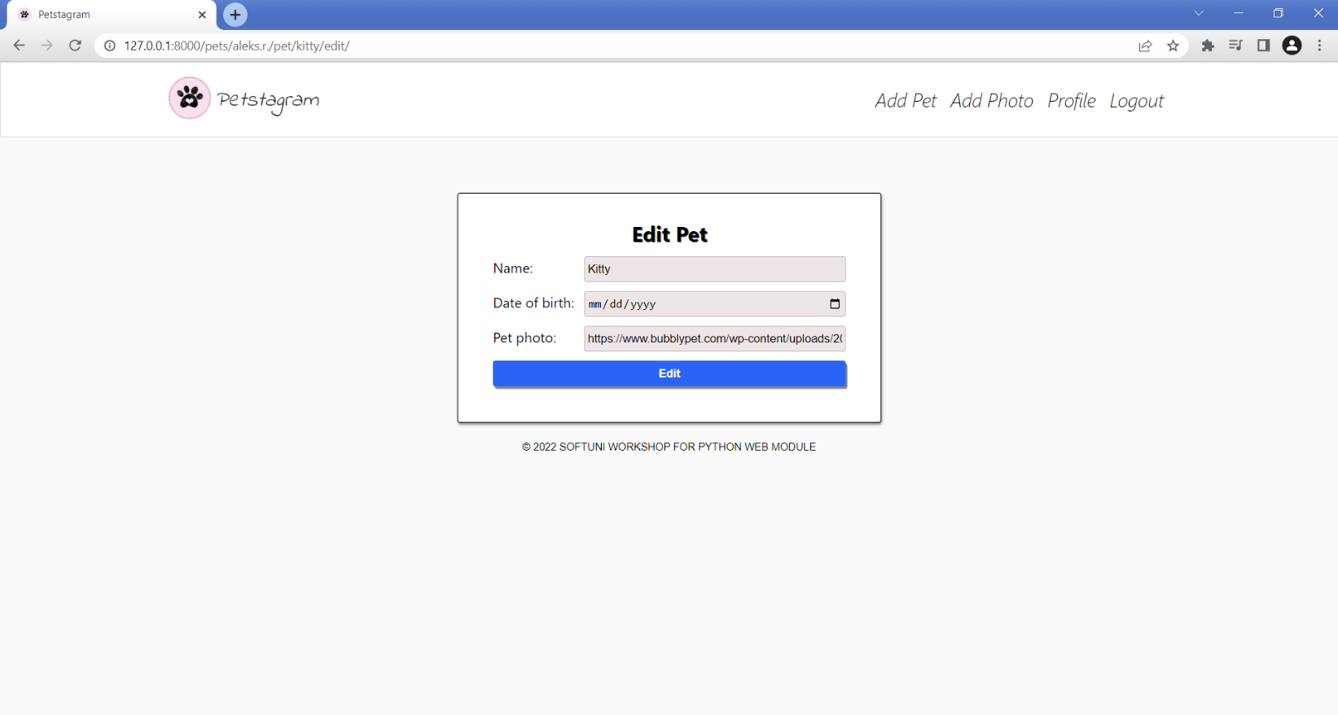

### Pet Delete Page

All pet info fields should be **visible** and **disabled**. If the user clicks on the "**Delete**" button the **pet is deleted** (but all its photos are **NOT** deleted), and the user is **redirected to the profile details page**. If the user clicks on the "**Go back**" button, they are **redirected to the pet details page**: 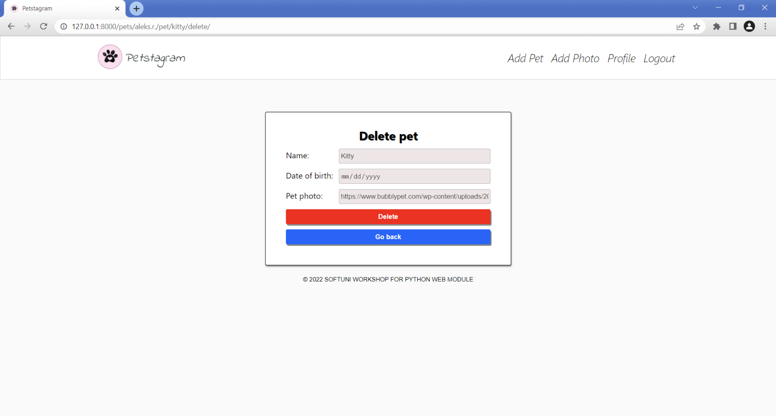

### Photo Add Page

The **visible fields** when adding a new photo are "**Pet Image**", "**Description**", "**Tag Pets**", and "**Location**". When the user successfully adds a photo, they are **redirected to the Home page**:

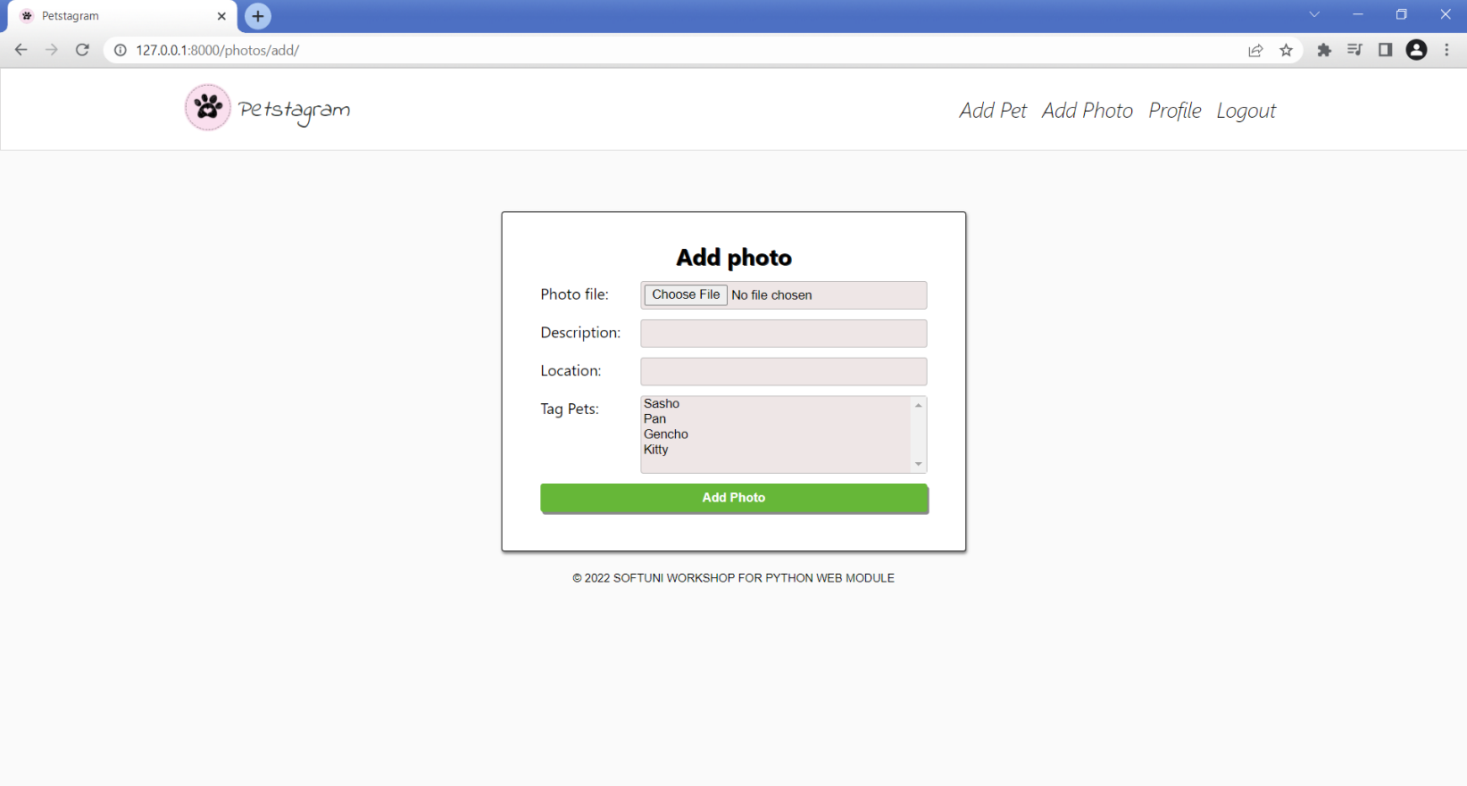

### Photo Details Page

When there **are pets photos**, the user sees **posts**, each consisting of:

* The **owner's name** (or **username**) and their **profile picture**
* **Edit and delete buttons** (visible only to the owner of the photo)
* The **location** (if one is added)
* The pet **photo**
* **Like** and **Share** buttons
* The total **count of likes** for the photo
* The **tagged** **pets** (if any are added) - if there is **more than one pet** tagged, they should be must be shown on **different lines**
* Photo **description** (if one is added)
* **Date** of publication (or edition)
* **Comment** from users
* **Comment Form** used to add comments to the photo

The **edit** button redirects to the **edit photo page**. The **delete** **button** **directly deletes the photo**. 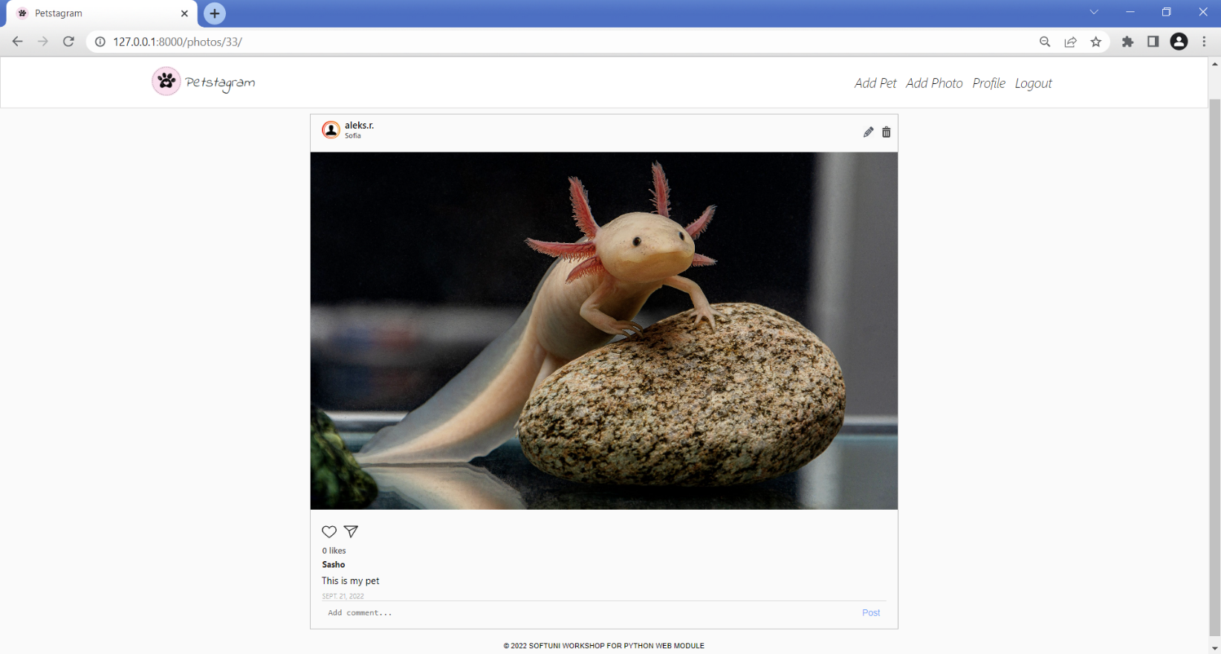

When a **comment is added**, it should be **visible** on the photo details page, **sorted** from the **oldest** (first) **to the** **latest** (last):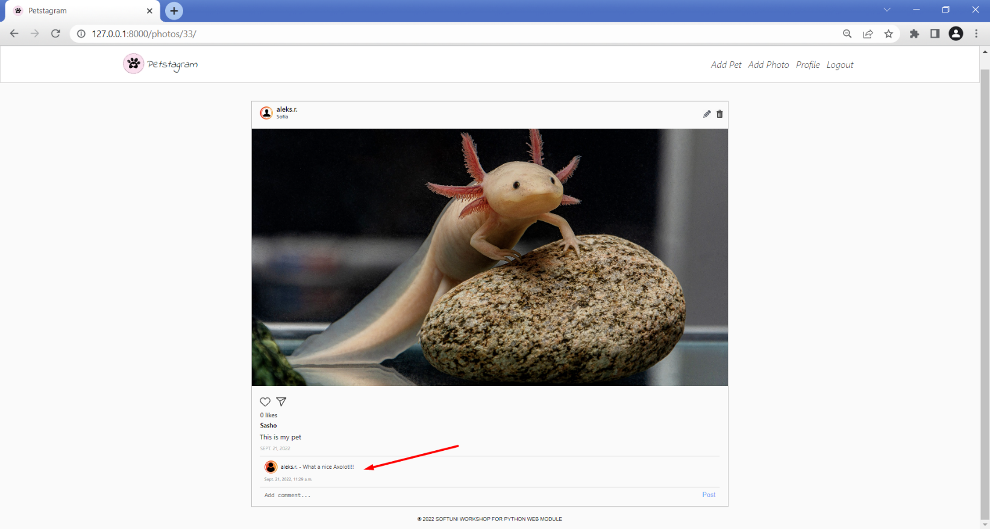

When there are added photos the **user profile changes** as shown below.

### Photo Edit Page

The visible fields when editing a photo are "**Description**", and "**Tag Pets**". The photo is **NOT editable**! When you click on the "**Edit**" button, the **photo info is updated**, and the user is redirected to the **details** page: Graphical user interface
